MACH4METAL

Metalworking machinery
Transito 21,
6909 DA BABBERICH
Netherlands
Tel. +31 (0)316 – 247123
Fax. +31 (0)316 - 247956

Account No: 66.52.13.883
IBAN : NL33 INGB 0665 2138 83
BIC : INGBNL2A

SKODA CNC RAM FLOOR BORER W 200 HB
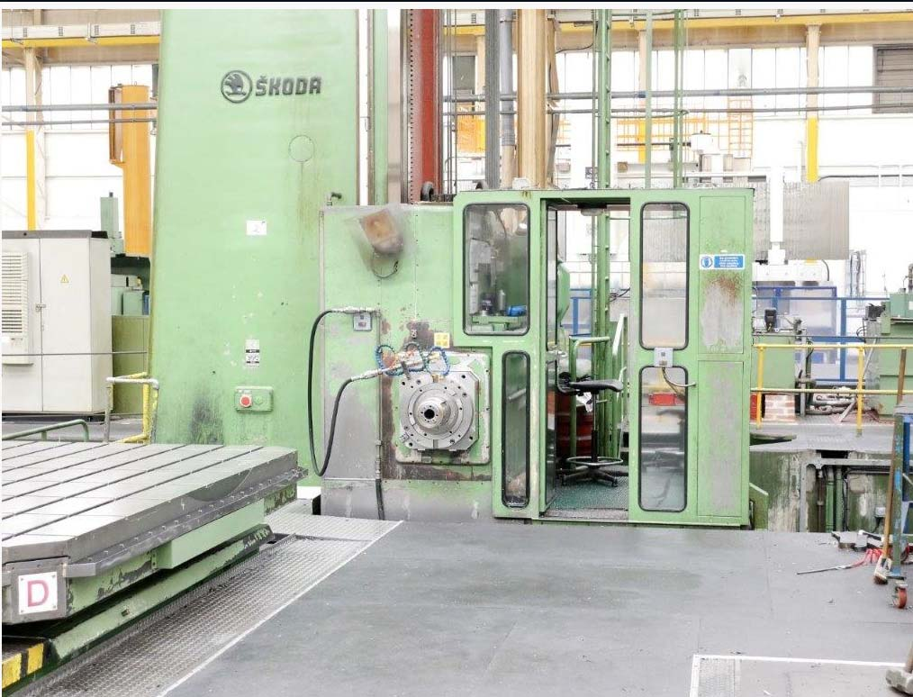
- Make : SKODA Pilzen
- Type : W 200 HB
- Serial : Ob 31628 S
- Age : 1999

- X Travel : 14.500
- Y Travel : 3.750
- W Travel : 1.600
- Z Travel : 2.000

- Spindle diameter Ø : 200
- Ram size : 520 X 520
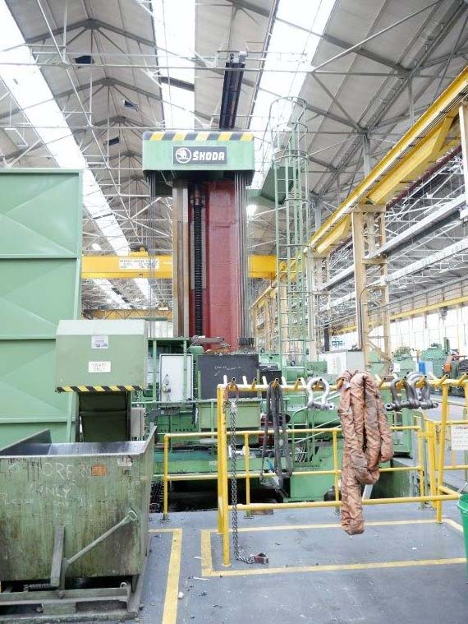
- Spindle motor : 77 Kw
- Spindle taper : ISO 50
- Spindle speed : 0.9 – 930

- Feed spindle / ram :1 - 3000
- Feed column / head : 1 – 8000

- Height of bed : 500
- Bed width : 2000
- Width column guide : 1700

- Rebuild in 1999 at Skoda
- New HeidenHain control TNC 430
- New Heidenhain scales
- New Motor / cable / Electric

- Incl. Milling head SKODA IFW 2-3 new 1999
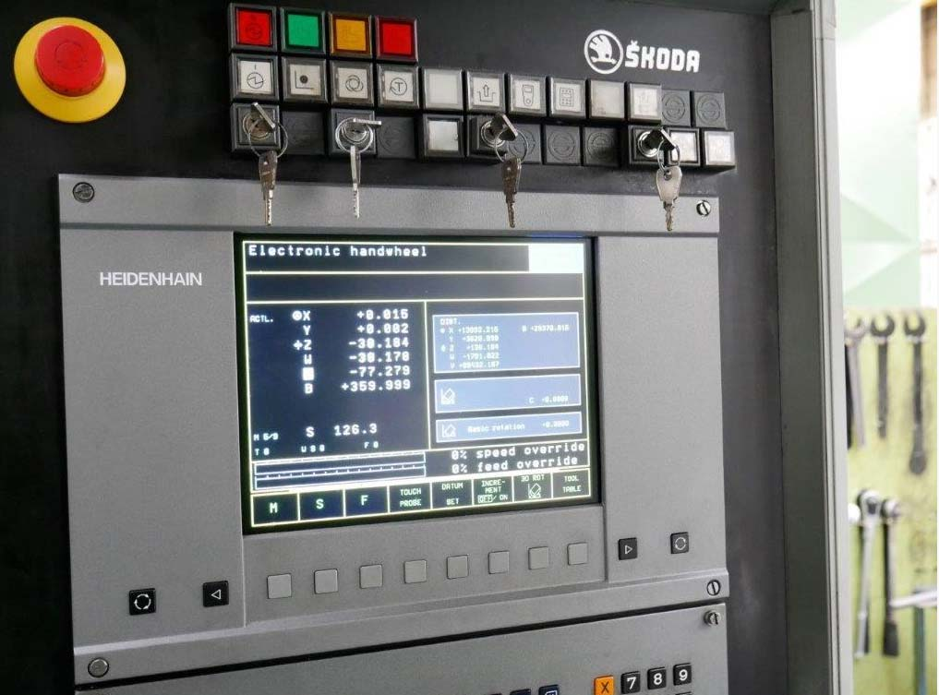
- Incl. Milling head SKODA IFW 3-A new 1999
- Incl. Milling head SKODA…. ANGLUAR
- Incl. chip conveyor / coolant / filtration system

- Optional SKODA S60 Table ( over CNC)
Size 3500 x 3500 x V Axis 2000 x 60 T
- Optional floorplates 11.200 x 8.400 x 410 mm

Please Note: The above information has been obtained to the best of our ability and belief from, and from the manufacturers where possible. It is given in good faith, but its accuracy can not be guaranteed. Accordingly, it will not form a representation or constitute contractual terms. We advise you to check any vital details!

